  - Screen Shots

1.1 Screen 1: Findings Information Screen
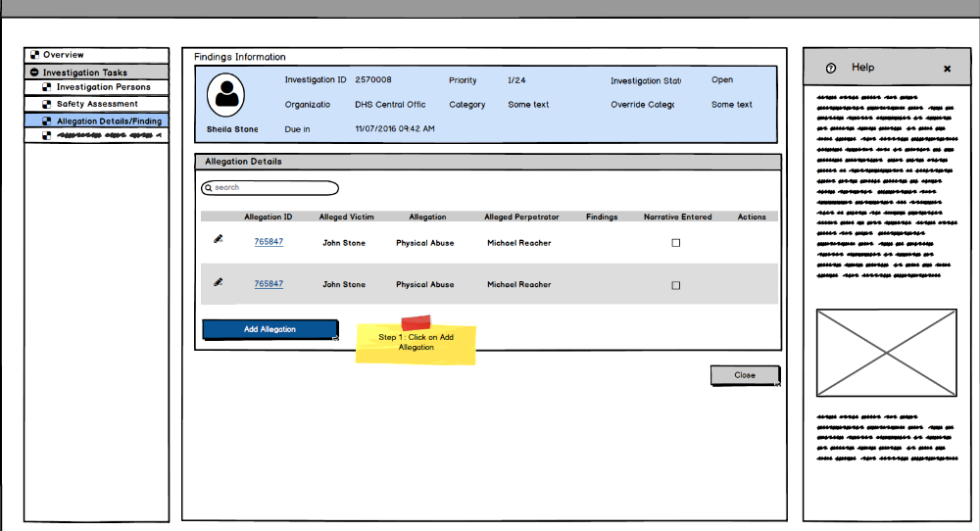
    - Screen Fields
Class.Attribute Name | Display Name | Type | Align | Size | Read Only | Calculation | Edit Mask | UI Validation
Header Section same as IV20 User Story 232
N/A | Findings Information | Hyperlink In Focus | L | N/A | T | N/A | N/A | N/A
N/A | Allegation Details | Group Box Header | L | N/A | T | N/A | N/A | N/A
N/A | <No Label> | First Column | C | N/A | T | N/A | N/A | This column can contain the pencil icon, which will navigate the user to the Findings Info screen
Investigation_Allegation_ID | Allegation_ID | Hyperlink/Display Text | L | N/A | T
INVESTIGATIONALLEGATION.allegedChildVictim | Alleged Victim | Display text | C | 22 | T | N/A | Last Name, First Name, Middle name | N/A
AllegationClassification.AllegationSuperTypeCode | Allegation Type | Display text | C | 100 | T | Domain code=AllegationCategory | N/A | N/A
INVESTIGATIONALLEGATION.allegedPerpetrator | Alleged Perpetrator | Display text | C | 22 | T | Domain code=ParticipantRole | N/A | N/A
ALLEGATIONCLASSIFICATION.classificationTypeCode | Findings | Display text | C | 30 | T | N/A | N/A | To display the findings for the corresponding Allegation from the value selected as per Screen 3
N/A | Narrative Entered | Checkbox | C | N/A | T | If the AllegationClassification.ClassificationNarrative is not null, display checked box else display unchecked box | N/A | System derived

1.1.2 Action Buttons/Hyperlinks
Label | Type | On Click Action/Navigation
Add Allegation | Button | Allegation Details screen is displayed (Screen 2).
Pencil | Icon | Finding Details screen is displayed for entering/modifying the Findings for the particular allegation
Allegation_ID | Hyperlink | Allegation Details screen (Screen 2) is displayed.
Delete | Hyperlink | On confirming the delete request, system will delete selected allegation; stays on this screen
Close | Button | User navigates back to Investigation Tasks screen (IV20a)
Help | Section Header | Specific screen related help will be displayed. This is a place-holder for now.

  - Screen 2: Allegation Details Screen
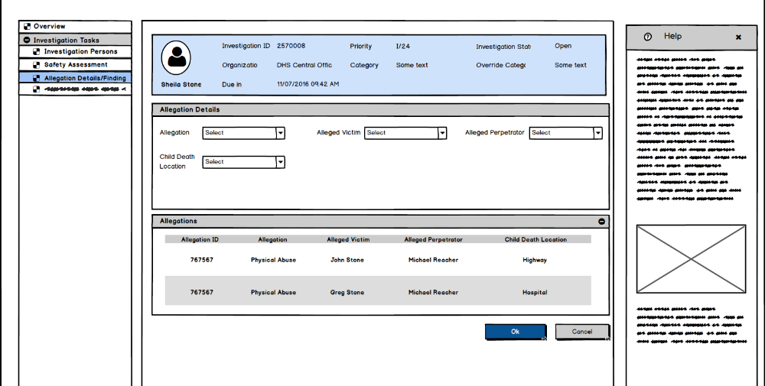
Buttons will be Apply, Save and Cancel

1.2.1 Screen Fields
Class.Attribute Name | Display Name | Type | Align | Size | Read Only | Calculation | Edit Mask | UI Validation
Header details same as IV20 User story 232.
N/A | Allegation Details | Group Box Header | L | N/A | T | N/A | N/A | N/A
ALLEGATIONCLASSIFICATION.allegationTypeCode | Allegation | Drop Down List | L | 30 | F | Domain Code: AllegationType | N/A | User selected. Default to Null. Mandatory field.
INVESTIGATIONALLEGATION.allegedChildVictim | Alleged Victim | Drop Down List | L | 100 | F | N/A | Last Name, First Name Middle Name | User Selected
 |  |  |  |  |  |  |  | Required Field
 |  |  |  |  |  |  |  | Default to Null
 |  |  |  |  |  |  |  | List populated from IV21 – S02 Investigation Persons Details with all established investigation persons(have person id) with role of Alleged Child Victim
 |  |  |  |  |  |  |  | See BR 2
INVESTIGATIONALLEGATION.allegedPerpetrator | Alleged Perpetrator | Drop Down List | L | 100 | F | N/A | Last Name, First Name Middle Name | User selected
 |  |  |  |  |  |  |  | Required Field
 |  |  |  |  |  |  |  | Default to Null
 |  |  |  |  |  |  |  | List populated from IV21 – S02 Investigation Persons Details with all established investigation persons(have person id) with role of Alleged Perpetrator
 |  |  |  |  |  |  |  | See BR 2
AllegationClassification.childDeathLocationCode | Child Death Location | Dropdown List | C | 100 | F | Domain code = ChildDeathLocation | N/A | No other validation for this field
 | Allegation | Section Header | L | 100 | F |  |  | All the allegation in the Findings information screen will be displayed here.
Allegation_ID | Allegation ID | Display Text | L |  | T |  |  | Static display of the Allegation ID
INVESTIGATIONALLEGATION.allegedChildVictim | Alleged Victim | Display text | L | 22 | T | N/A | Last Name, First Name Middle Name | N/A
INVESTIGATIONALLEGATION.allegedPerpetrator | Alleged Perpetrator | Display text | L | 22 | T | N/A | Last Name, First Name Middle Name | N/A
ALLEGATIONCLASSIFICATION.allegationTypeCode | Allegation | Display text | L | 30 | T | Domain code=AllegationType | N/A | N/A
AllegationClassification.ChildDeathLocationCode | Child Death Location | Display Text | L | 100 | F | Domain Code = ChildDeathLocation | N/A
 |  |  |  |  |  |  |  | System Populated

1.2.2 Action Button/Hyperlinks
Label | Type | On Click Action/Navigation
Apply | Button | The created/modified values are saved and displayed in the same screen. Allegations list below should have the updated changes.
Save | Button | The created/modified values are saved and displayed in the Findings Information screen
Cancel | Button | Discard the changes and user navigates to Findings Information Screen (Screen 1)

  - Screen 3: Findings Details Screen
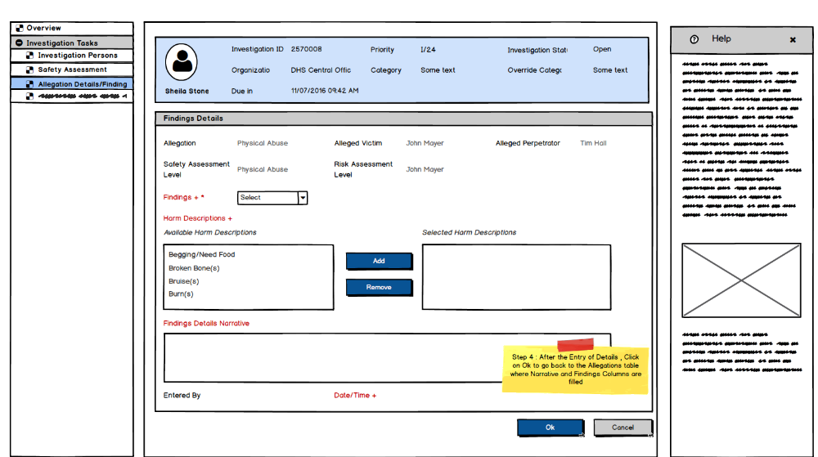
Findings Details Narrative (should not be in red; however, it is a mandatory field)
This screen will also have Apply,Save,Cancel

1.3.1 Screen Fields
Class.Attribute Name | Display Name | Type | Align | Size | Read Only | Calculation | Edit Mask | UI Validation
Header details are the same as Investigation Overview Screen (IV20)
N/A | Findings Details | Group Box Header | L | N/A | T | N/A | N/A | N/A
ALLEGATIONCLASSIFICATION.allegationTypeCode | Allegation | Display text | L | 30 | T | N/A | Domain code=AllegationType | N/A
INVESTIGATIONALLEGATION.allegedChildVictim | Alleged Victim | Display text | L | 22 | T | N/A | Last Name, First Name Middle Name | N/A
INVESTIGATIONALLEGATION.allegedPerpetrator | Alleged Perpetrator | Display text | L | 22 | T | N/A | Last Name, First Name Middle Name | N/A
SafetyResponse.SafetyDecision | Safety Assessment level: | Display text | L | 100 | T | N/A | N/A | N/A
RiskAssessment.FinalRiskLevelCode | Risk Assessment level: | Display text | L | 100 | T | N/A | N/A
ALLEGATIONCLASSIFICATION.classificationTypeCode | Findings | Drop Down List | L | 100 | F | Domain Code: | N/A | User selected
 |  |  |  |  |  | ClassificationType | N/A | See BR 1
 |  |  |  |  |  |  | N/A | Required Field
N/A | Harm Descriptions | Group Box Header | L | N/A | T | N/A | N/A | N/A
HARMDESCRIPTIONS.harmDescriptionsCode | Available Harm Descriptions | Mover Box | L | 30 | F | Domain Code: | N/A | System populated
 |  |  |  |  |  | HarmDescription | N/A | User selected
 |  |  |  |  |  |  | N/A | Not required
HARMDESCRIPTIONS.harmDescriptionsCode | SelectedHarm Descriptions | Mover Box | L | 30 | F | N/A | N/A | User selected
 |  |  |  |  |  |  |  | Not required
ALLEGATIONCLASSIFICATION.classificationNarrative | Findings Details Narrative | Text field | L | 2000 | F | N/A | N/A | User input
 |  |  |  |  |  |  |  | Required Field
ALLEGATIONCLASSIFICATION.createdBy | Entered By | Display text | L | 22 | T | N/A | Last Name, First Name MI | Shows the name of the logged in worker that entered the classification
 |  |  |  |  |  |  |  | Will be populated when the 'finding' hyperlink is clicked on IV13-S02 for the first time.
ALLEGATIONCLASSIFICATION.createdDate | Date/Time | Display text | L | 24 | T | N/A | MM/DD/YYYY ##:## XM (TZ) | Date and time that the classification was entered
 |  |  |  |  |  |  |  | Will be populated when the finding hyperlink is clicked on IV13-S02 for the first time.

1.3.2 Action Button/Hyperlinks
Label | Type | On Click Action/Navigation
Apply | Button | The created/modified values are saved and displayed in the same screen
Save | Button | The created/modified values are saved and displayed in the Findings Information screen
Cancel | Button | Discard the changes on confirmation and user navigates to Findings Information Screen (Screen 1)

- Story
As an Investigation Worker, I need to document allegation findings so that I can substantiate or unsubstantiate the allegations.

- Notes
- Demo Steps
Pre-condition for this user story:
An intake must be linked to an Investigation (IV01b).
Allegation must already exist for the intake
Flow 1: To Add/Edit an Allegation record
- Step 1: Login to the USFN application with the following credentials
  - Username: samweaver
  - Any Password works.
‘My Organizer’ screen is displayed after successful login.
- In the “My Investigation” applet, click on “View All” link
InvestigationWorkload will be displayed with the linked investigation ID
- Click on the Investigation ID link
Investigation Overview is displayed with the details of the Intake displayed.
- Select the Investigation Tasks in the left Panel
Investigation Task cards is displayed.
- Click on Allegations/Finding link.
Findings Information Screen is displayed with all the allegations as per the Intake.
Click on Add Allegation button.
- Allegation Details screen is displayed as per Screen 2.
- Select Allegation, Alleged Victim, Alleged Perpetrator, Child death Location (if needed) and click on OK.
The created Allegation is displayed in Screen 1 with the Allegation_ID (hyperlink) and delete icon.
[[Note that Allegation record will ONLY be editable when created at the Investigation phase. Allegations from the Intake are not editable/cannot be deleted.]]
- Click on the Allegation_ID
Allegation details screen is displayed with the pre-filled selected values.
- Modify any of the value and click on OK.
Updated values are reflected in the Findings Information Screen (Screen 1).

Flow 2: To enter Findings for an Allegation record
- Step 1: Login to the USFN application with the following credentials
  - Username: samweaver
  - Any Password works.
‘My Organizer’ screen is displayed after successful login.
- In the “My Investigation” applet, click on “View All” link
InvestigationWorkload will be displayed with the linked investigation ID
- Click on the Investigation ID link
Investigation Overview is displayed with the details of the Intake displayed.
- Select the Investigation Tasks in the left Panel
Investigation Task cards is displayed.
- Click on Allegations/Finding link.
Findings Information Screen is displayed with all the allegations as per the Intake.
Click on the pencil (edit) icon to the left of the record.
Finding Information screen (Screen 3) is displayed.
- Select the Findings, Harm Factors and enter the narrative and click on OK.
Findings is displayed in Screen 1 and Narrative checkbox is checked.

- Acceptance Criteria
SCREEN 1
# | Requirement | Execution Event | Status
1 | The ‘delete’ hyperlink should only be available to the user for allegations entered at the investigation level | Page Load
2 | The values shown in the Allegation Details grid on the Findings Information screen will be based on the latest findings information. | Page Load
3 | Allegation_ID will be a Hyperlink for all the records. For Allegations from Intake, clicking on the link will display Read-only version of the Allegation details (Screen2)  For allegations created from the Investigation phase, the link will display the editable screen of Allegation details (Screen 2) | Page Load
SCREEN 2
# | Requirement | Execution Event | Status
1 | If any of the following allegation information is modified on Allegation Details screen:  - “Alleged Child Victim”  - “Alleged Perpetrator”  - “Allegation ”  Then clear the following information on IV13 –S03 Findings Details for the allegation:  - “Findings”  - “Findings Details Narrative”  Warn User prior to this action.  “You have changed Allegation data. This will clear classification type and narrative. Do you want to continue?”
2 | Do not allow duplicate entry of  Allegation (Allegation. AllegationType) , Alleged Victim and Alleged Perpetrator.  Message: You cannot ADD duplicate Allegation combination OF Alleged CHILD Victim, Alleged Perpetrator AND Allegation TYPE”
3 | Child Death Location is not a mandatory field and may always be enabled.
4 | Allegation, Alleged Victim and Alleged Perpetrators are mandatory fields.
5 | Alleged Victims dropdown will have the values of all the Investigating Persons with role as AV and Alleged Perpetrator dropdown will have all the Investigating Persons with role as AP
Screen 3:
# | Requirement | Execution Event | Status
1 | Findings, Findings Narrative are mandatory fields:  Message to be displayed:  Findings is a required field.  Findings Details Narrative is a required field.

- Seed Data
Dropdown data.

- Tables Required
INVESTIGATION
INVESTIGATION_ALLEGATION
ALLEGATION_CLASSIFICATION
ALLEGATION
HARM DESCRIPTIONS
RISK_ASSESSMENT
SAFETY_ASSESSMENT
SAFETY_RESPONSE

